**WordCloud Result**

1. **For the wikipedia Page**

**Legal**

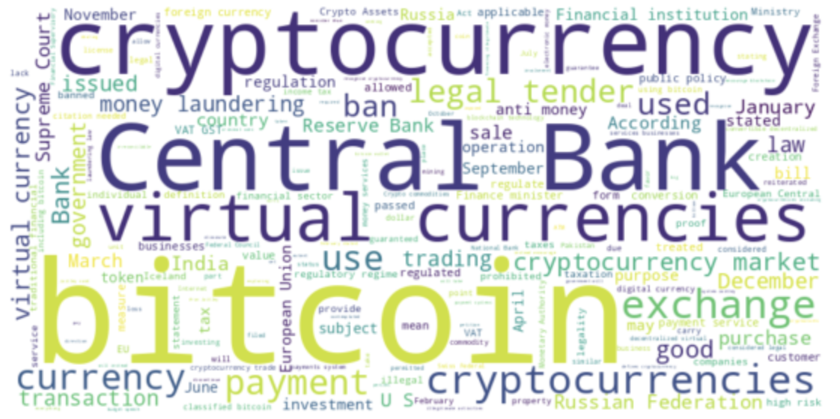

From the wordcloud, we are able to see that for countries that are legal with the cryptocurrency, there are several words like “payment”, “exchange”, “transaction”, “purchase” and so on, it is reasonable to infer that these countries might use cryptocurrency as a transaction methods. There are also several negative words like “laundering” or “anti money”.

**Illegal**

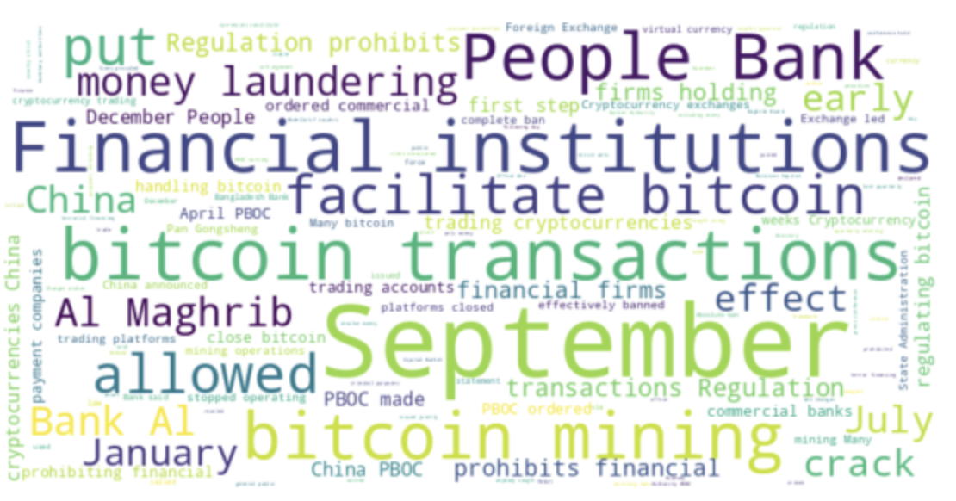

**Do text frequency, do word cloud after Tfidf**

From the wordcloud, we are able to see that for countries that are illegal with the cryptocurrency, there are several key words like “bitcoin mining”, “bitcoin transaction”, “money laundering” and so on. It is interesting that “money laundering” is something that are mentioned a lot.

**Other**

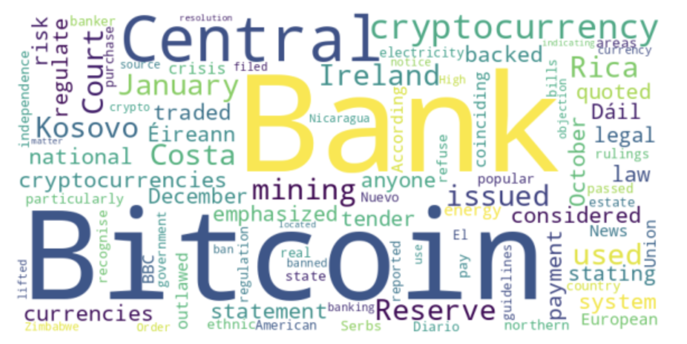

From the wordcloud, we are able to see that some of the keywords are “mining”, “reserve”, “central” or “issued”.

1. **For the articles scraped from the article reference page**

**Legal**

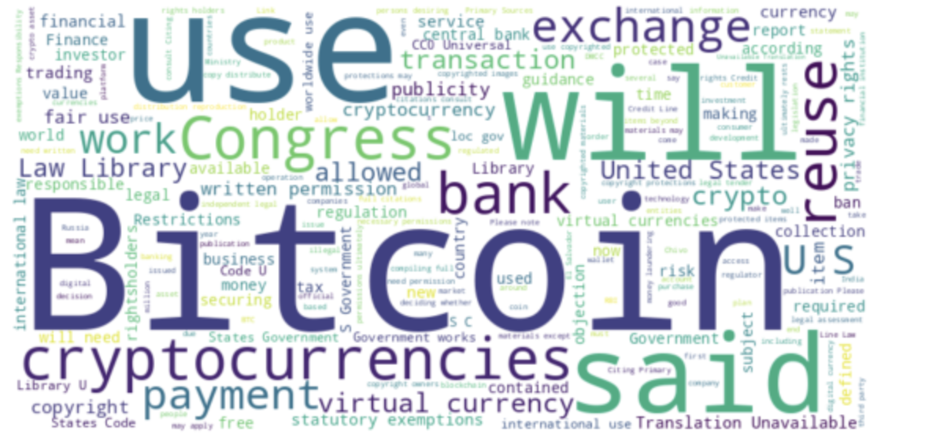

For the countries that are legal with the cryptocurrency, some keywords are “reuse”, “copyright”, “written permission” and “privacy rights”. Some of the keywords are consistent with the keywords we got from the wikipedia page like “payment” and “exchange”.

**Illegal**

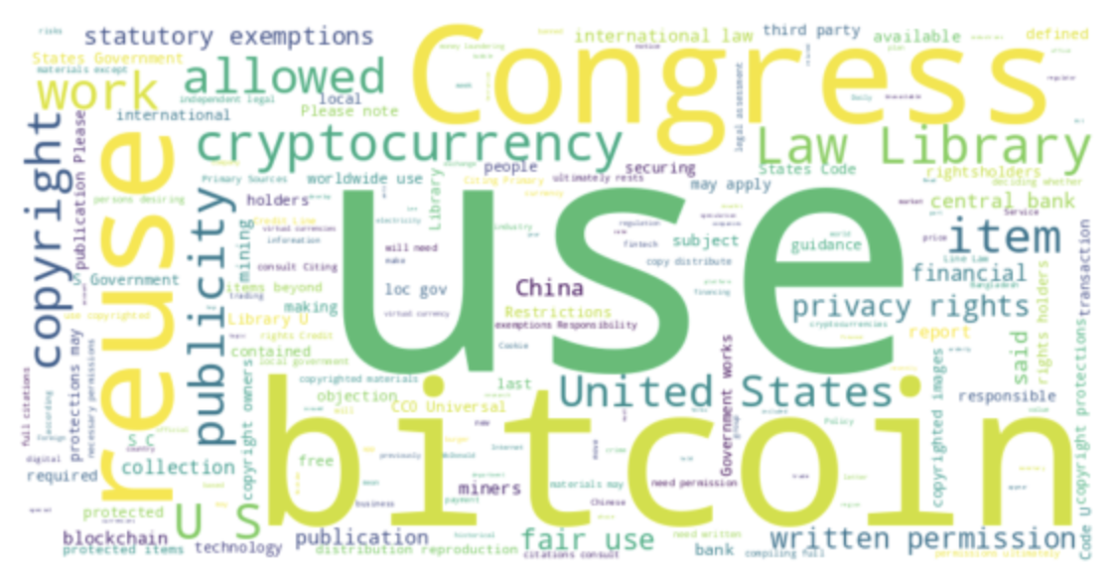

For the countries that are illegal with the cryptocurrency, some keywords are “fair use”, “publication”, “responsible” and “statutory exemptions”.

**Other**

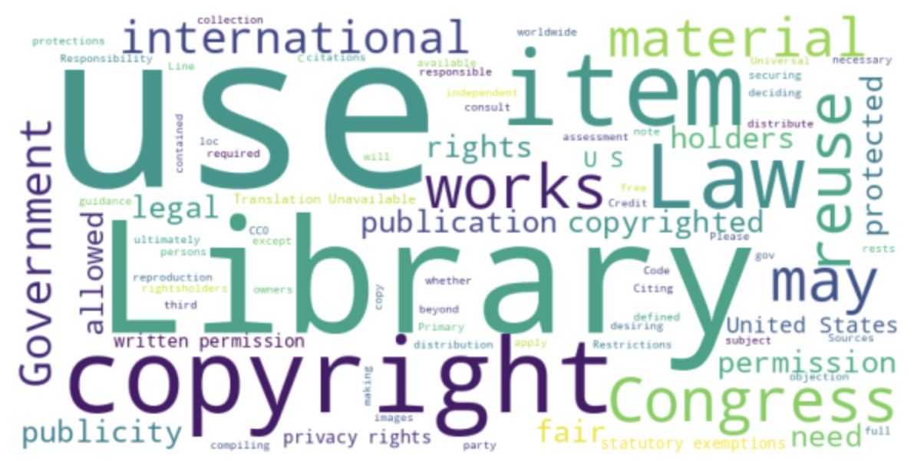

For the remaining countries, there are some keywords like “reuse”, “government”, “copyrights”, “holders”.

**Visualization of the Topic Modeling Results**

1. **Topic Modeling Results for wikipedia page**

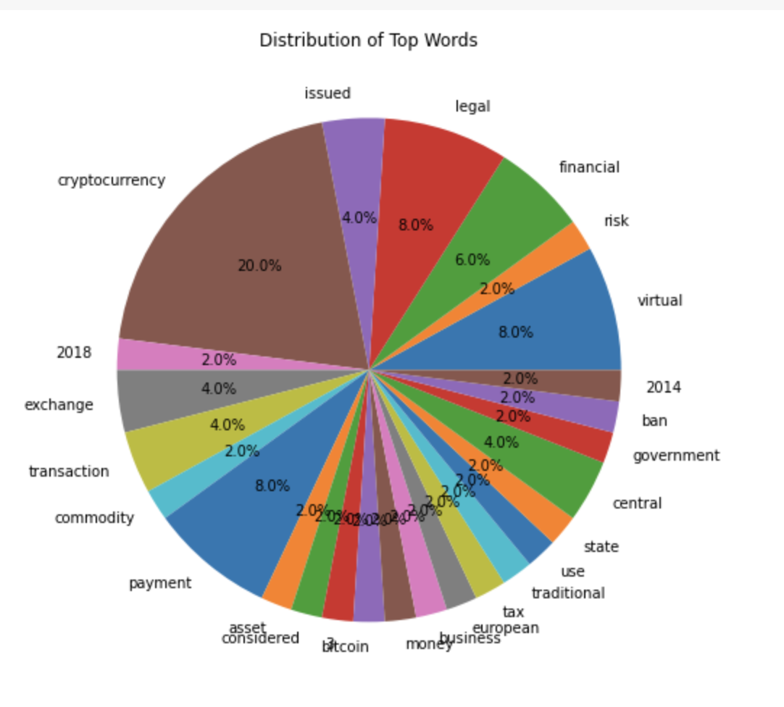

From the pie chart, we can see some top topics are “cryptocurrency”, “legal”, “virtual”, “financial”, “exchange”, and “central”.

1. **Topic Modeling Results for articles**

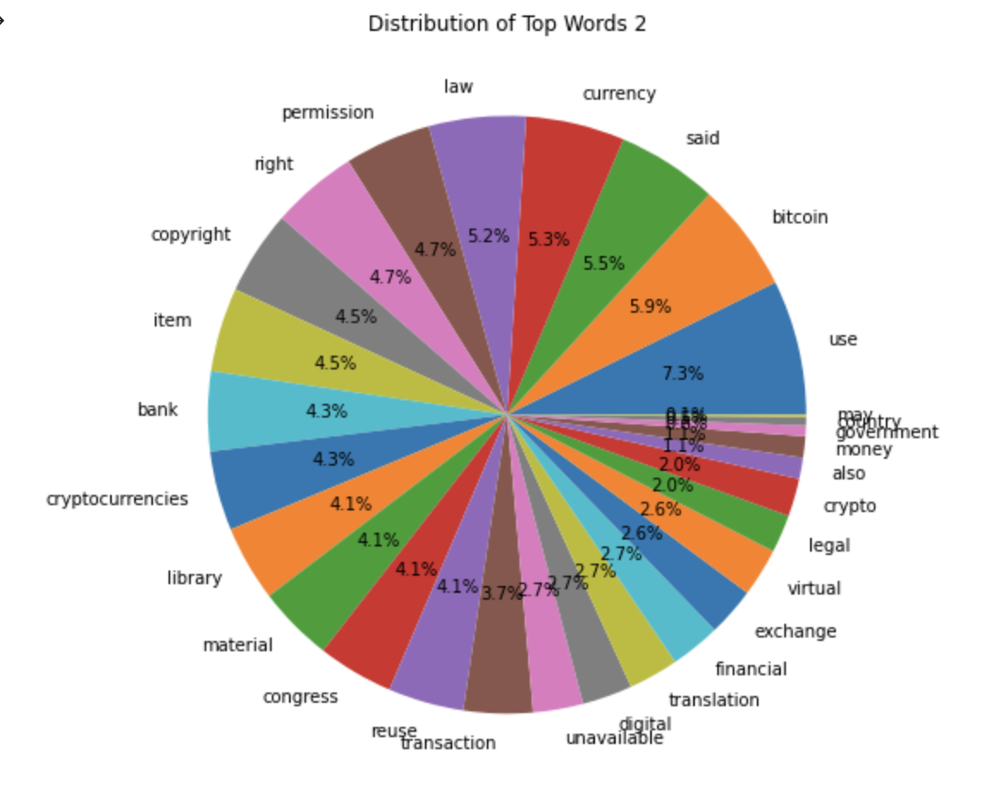

From the pie chart above, we can see some top topics are “use”, “bitcoin”, “said”, “law”, “permission” and so on.

1. **Topic Modeling Results for wiki**

* **Legal**

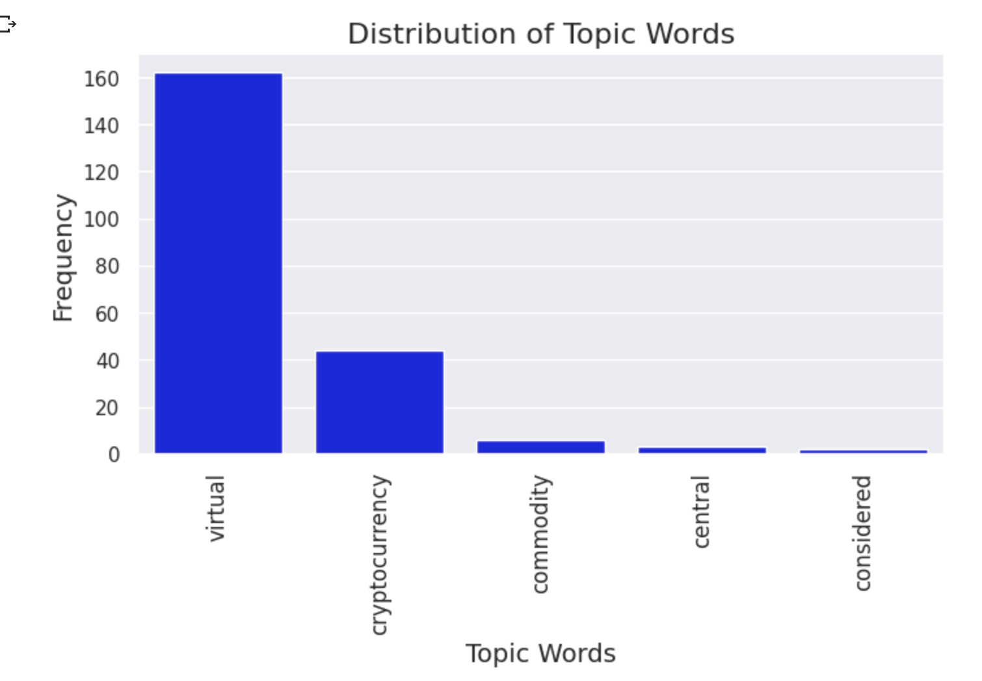

From the graph, we can see that the top 5 topic words for legal countries are virtual, cryptocurrency, commodity, central and considered.

* **Illegal**

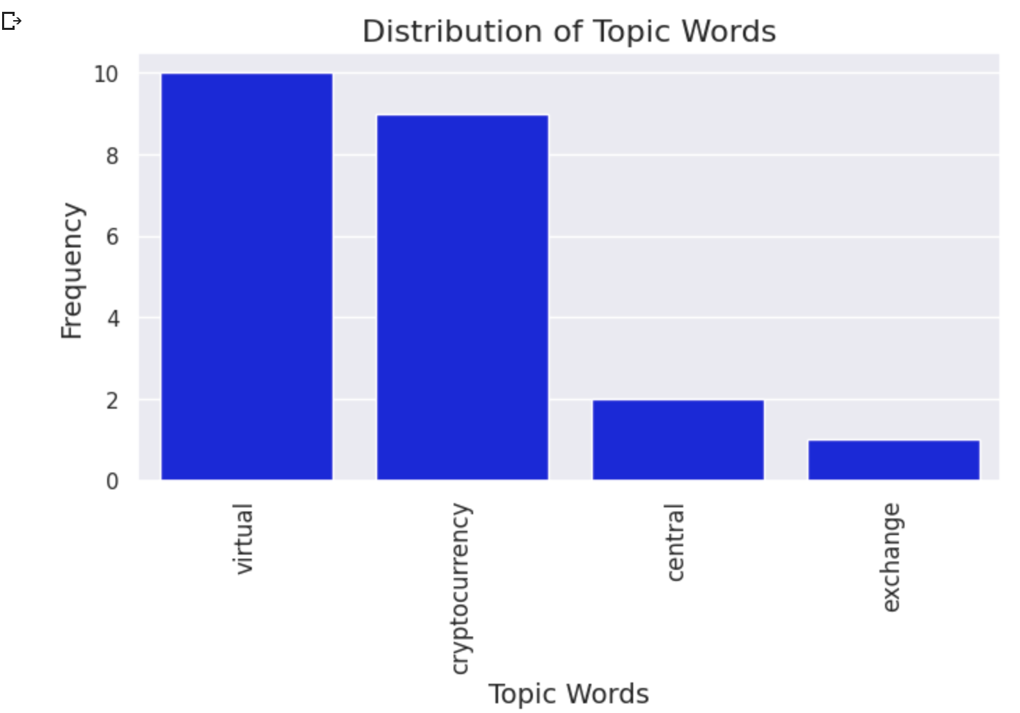

From the graph, we can see that the top 4 topic words for illegal countries are virtual, cryptocurrency, central and exchange.

* **Other**

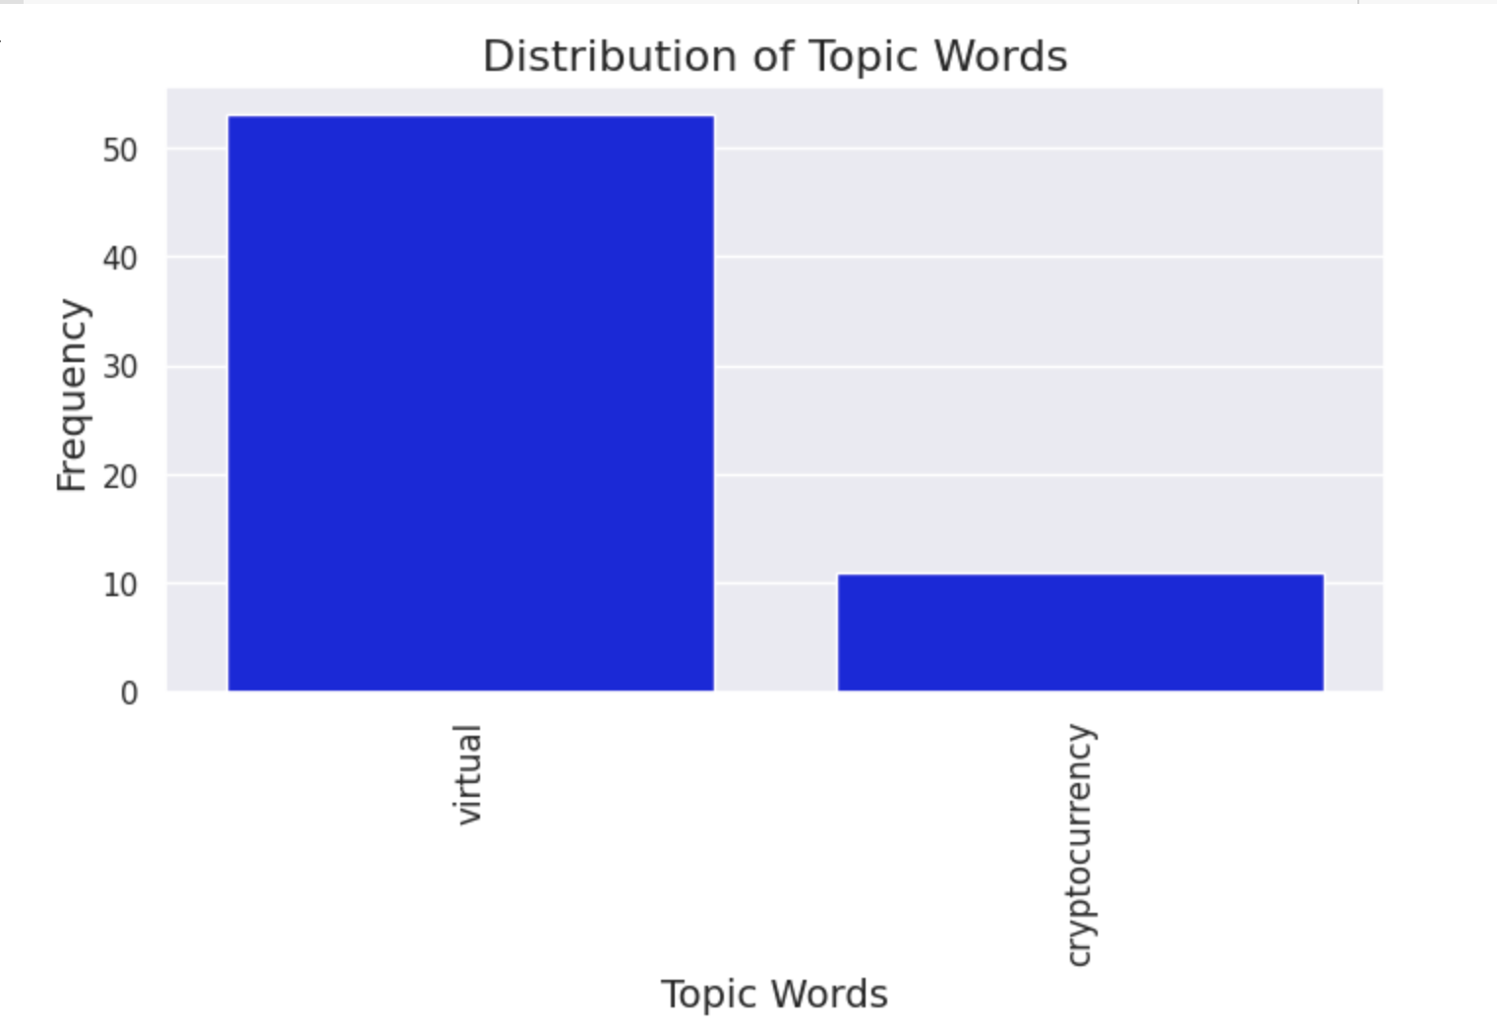

From the graph, we can see that the top 2 topic words for other countries are virtual and cryptocurrency.

1. **Topic Modeling Results for article**

* **Legal**

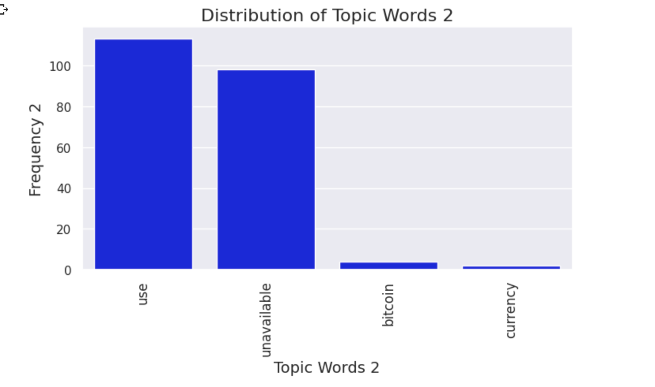

From the graph, we can see that the top 3 topic words for legal countries are use, bitcoin and currency.

* **Illegal**

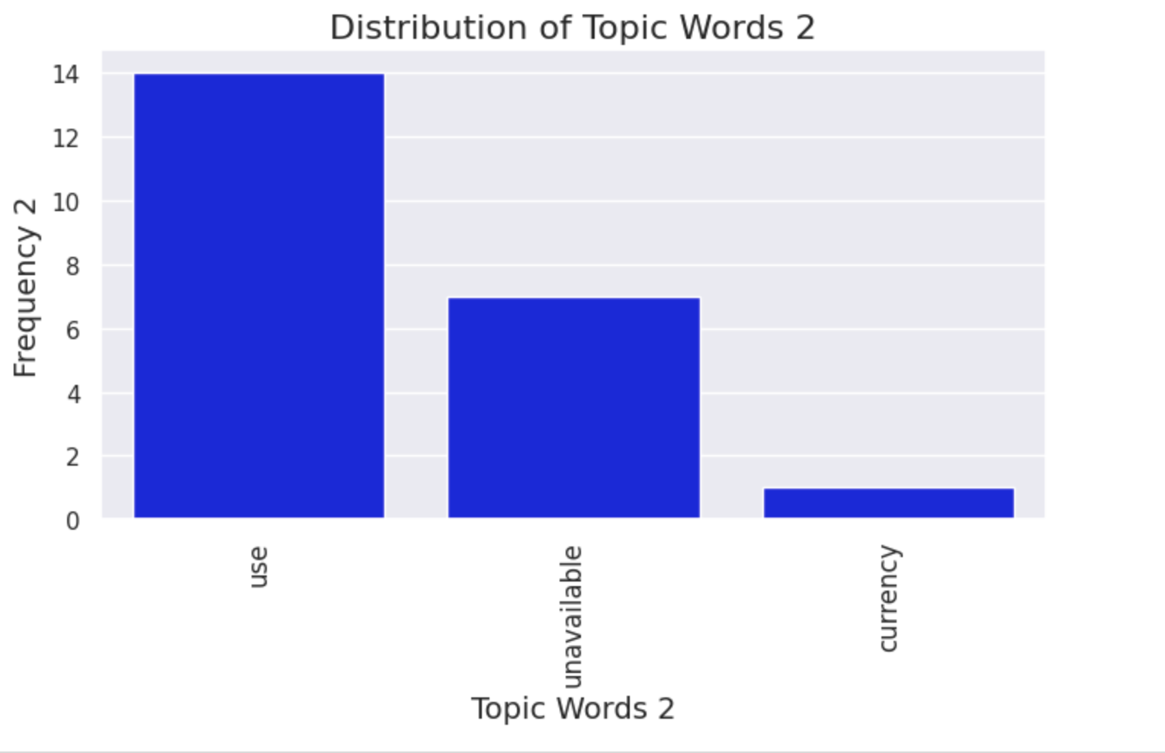

From the graph, we can see that the top 2 topic words for illegal countries are use, currency.

* **Other**

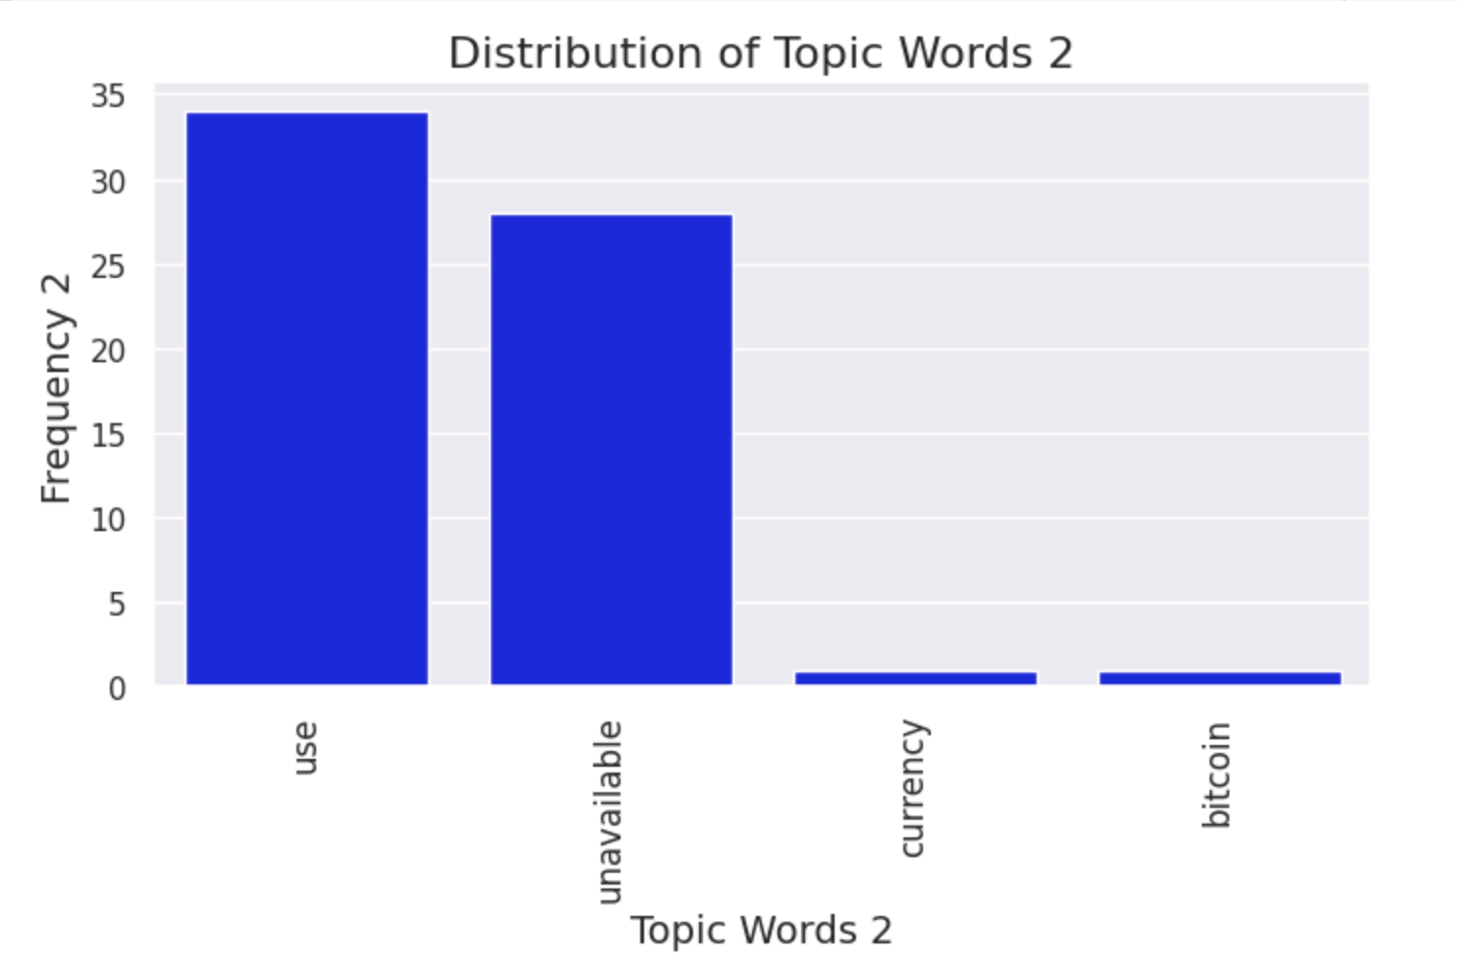

From the graph, we can see that the top 3 topic words for other countries are use, currency and bitcoin.

**For the wikipedia Page**

**Legal**

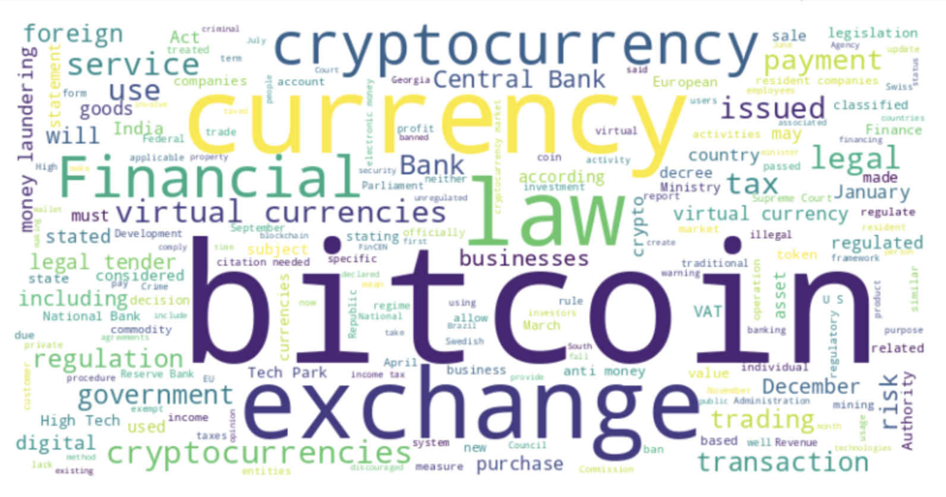

Central Bank: Central banks are highly important institutions in the world of finance, serving as the primary authorities responsible for the issuance and implementation of various financial policies. These institutions are typically established by governments to act as the regulatory body overseeing the monetary policies of a country or a group of countries. As mentioned in the wiki page, central banks for several countries are in charge of the banning/not banning the use of cryptocurrency. **Central banks play a crucial role in regulating the monetary system and financial stability of a country, including the integration of cryptocurrencies into the existing financial system.**

eg.

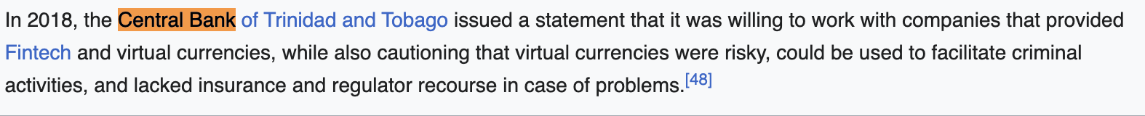

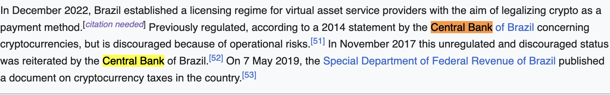



December: No obvious relationship between December and the legal status of these countries.

For example, December 2017 was a significant month for Bitcoin, the most well-known cryptocurrency. During that month, the value of Bitcoin reached an all-time high of almost $20,000 USD per coin. This event marked a turning point in the mainstream adoption of cryptocurrencies and generated significant media attention.

<https://www.coindesk.com/markets/2017/12/29/from-900-to-20000-bitcoins-historic-2017-price-run-revisited/>

Also, for lots of countries, they announce their regulation/policies on bitcoin in December.

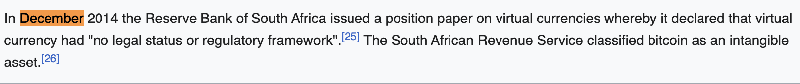





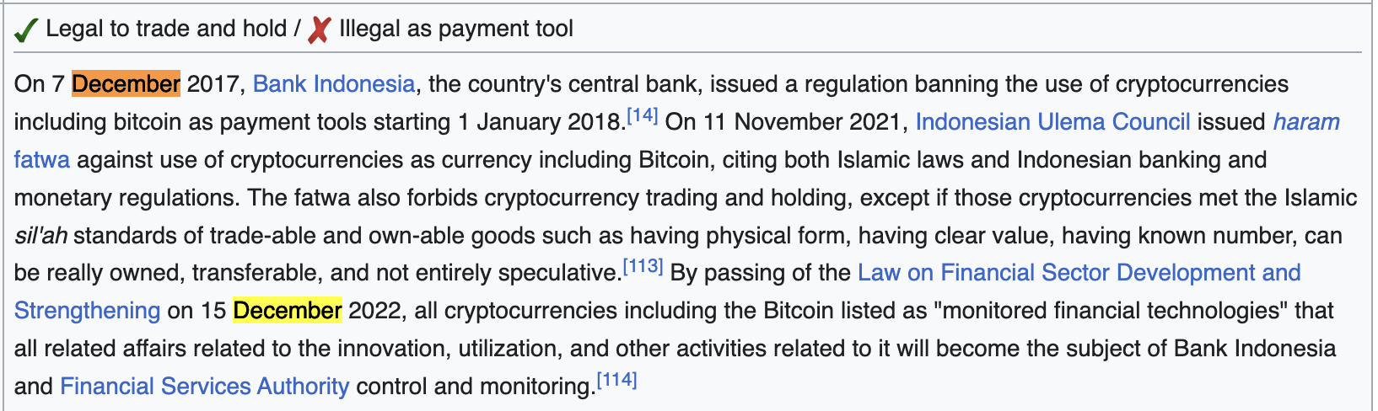

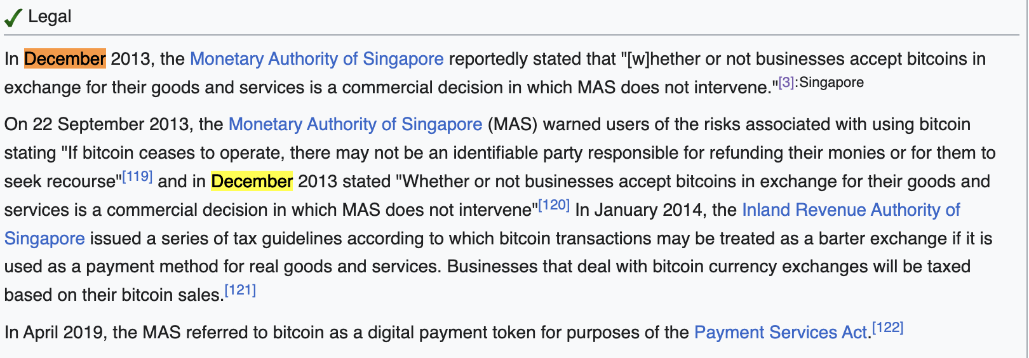

Tech-park:

High Tech Park (HTP) is a special economic zone located in Minsk, the capital city of Belarus. It was established in 2005 with the aim of creating a favorable environment for the development of high-tech industries, such as information technology (IT), software development, and electronics.

HTP offers a range of benefits to companies operating within the zone, including tax incentives, exemptions from customs duties and value-added tax, and streamlined procedures for obtaining permits and licenses. The park is also home to a number of business incubators and innovation centers, which provide support to startups and early-stage companies.

HTP has attracted a large number of domestic and international companies, including many well-known names in the IT and software development industries. As of 2021, there were over 800 companies operating within HTP, employing more than 50,000 people.

In addition to its economic benefits, HTP has also played a significant role in the development of Belarus' IT sector and has helped to position the country as a hub for innovation and technology. The park has been recognized by the World Bank and other international organizations as a model for economic development and has become an important contributor to Belarus' economy.

**Illegal**

Not many countries: only 8 countries

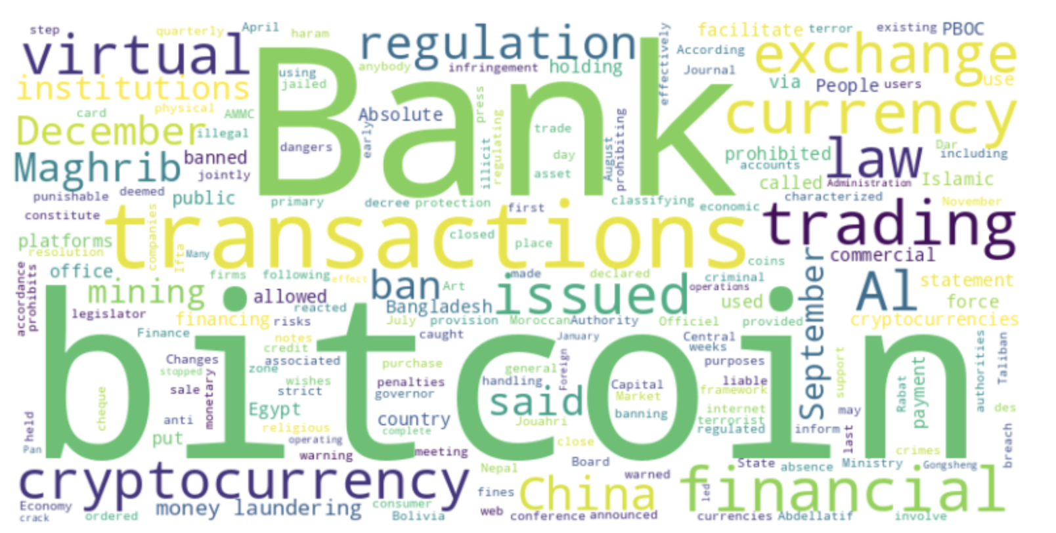

Al Maghrib: the name for the bank of Morocco, only associated with the decisions made by Morocco

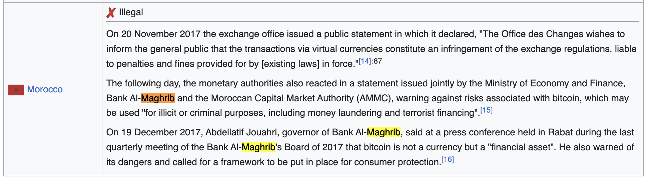

December: Some countries issues their policies on December, but not that frequent compared to legal countries.

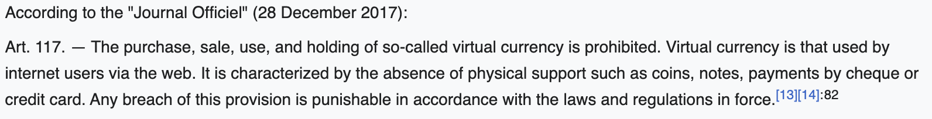

September: Same as December, no obvious relationship

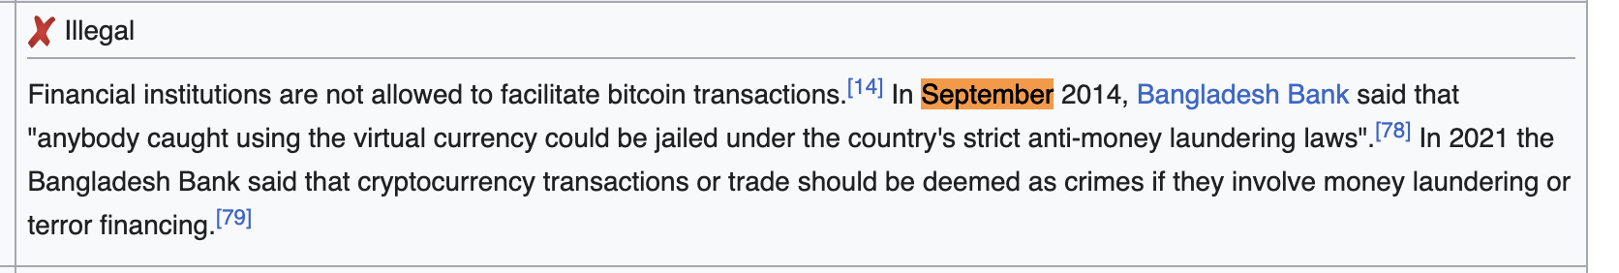

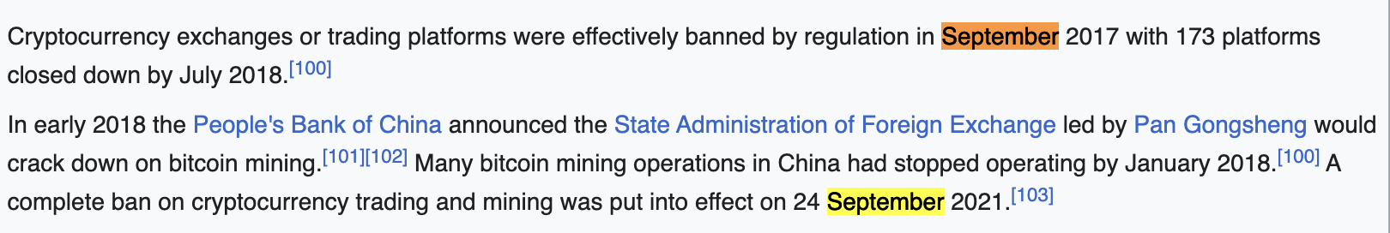

Money laundering: common concern for cryptocurrency. Cryptocurrencies allow for the transfer of funds without the need for intermediaries such as banks or financial institutions, which can make it difficult to track and monitor transactions. This creates opportunities for criminals to use cryptocurrencies to launder money or engage in other illegal activities. Cryptocurrencies provide an attractive option for money laundering because of their relative anonymity and the ability to quickly transfer funds across borders without the need for intermediaries.

**Others**

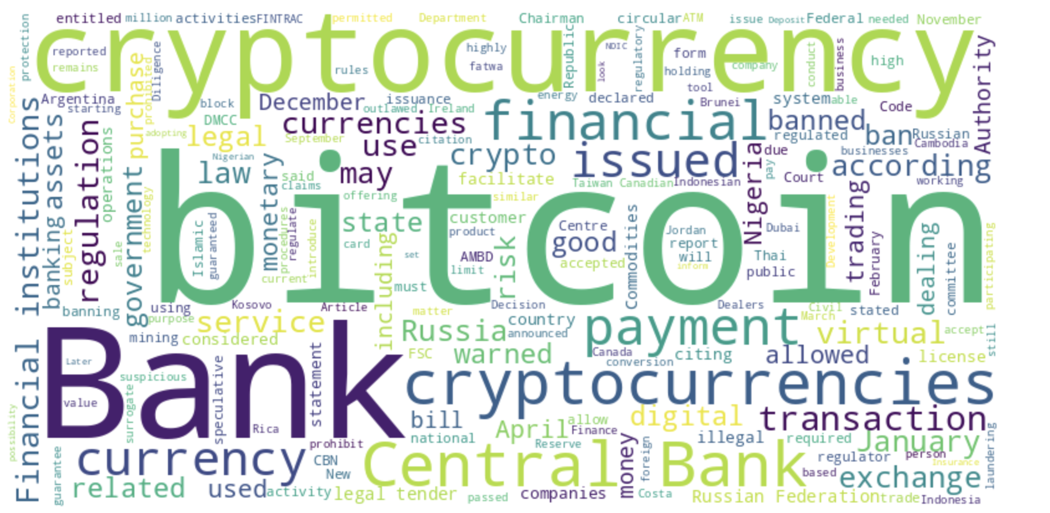

Bank: One reason for the frequent occurrence of the word “bank” is because for many countries, although cryptocurrency is legal, they are “banking ban” or “discouraged” by the bank.

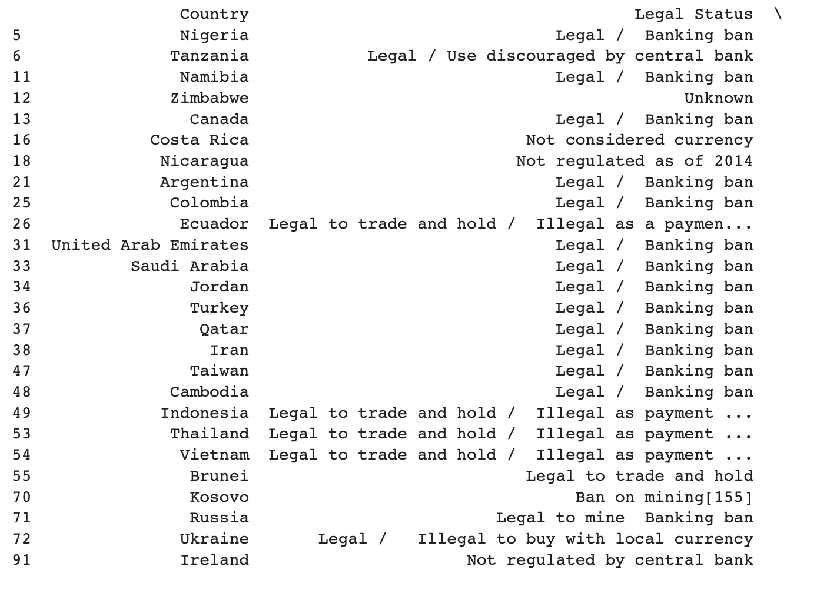

April: no obvious association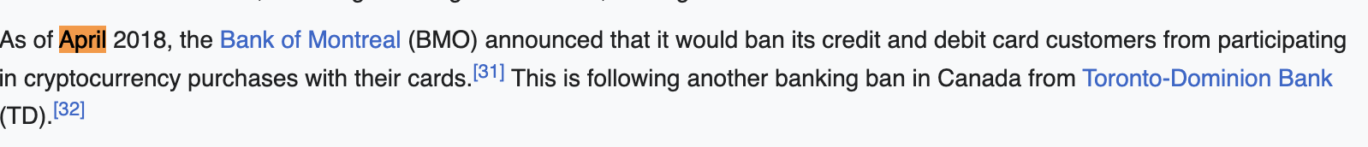

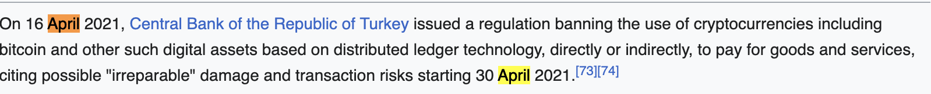

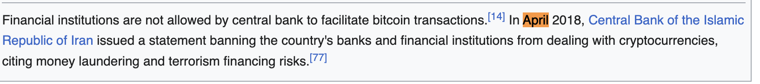

Financial institutions:

1. Some financial institutions are not allowed by central bank to facilitate bitcoin transactions, central bank take the relative absolute control on the bitcoin transaction



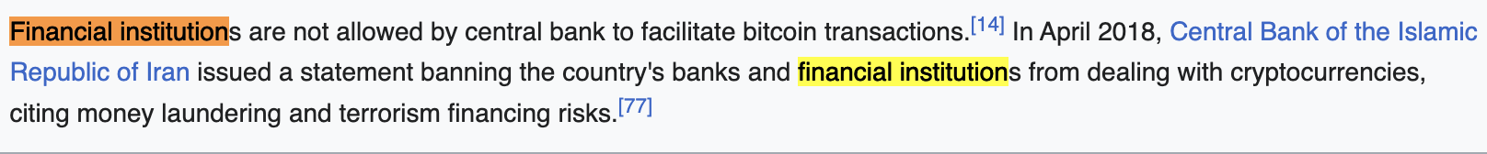



January: no obvious association

AMBD:

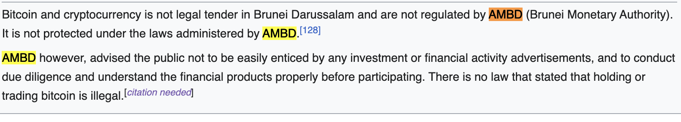

DMCC:

